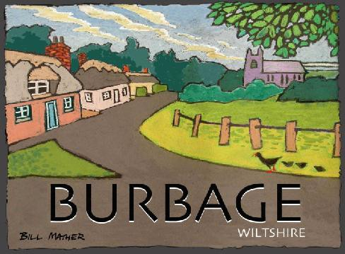
Burbage Neighbourhood Plan

Pre-Submission Draft Plan Consultation

Response Form

Following extensive consultation and research, a draft Neighbourhood Plan for Burbage is ready to read and comment on in accordance with Regulation 14 of the Neighbourhood Plan (General) Regulations 2012. The plan will be available at events in the village, from the Parish Council and online at:

http://burbage-pc.org.uk/publications.php?dir=Neighbourhood%20Planning&by=date&order=asc

The Plan is accompanied by a Sustainability Appraisal (SA) Report and a Site Selection Report (SSR).

Responses may be made online, or in writing using this form. All comments must be received within 6 weeks of the consultation start date, that is by midnight on November 12th.

Please return the form either by email to clerk@burbage-pc.org.uk, or by post to Cllr Pearce, 6 Ailesbury Way, Burbage SN8 3TD

Comments will be recorded and will form part of the Consultation Statement that has to accompany the Plan. For this reason and also to help us keep you informed of future developments, please start by giving your name and address.

Name: ……………………………………………………………………………………………………………………

Address: ……………………………………………………………………………………………………………………

……………………………………………………………………………………………………………………

……………………………………………………………………………………………………………………

e-mail: ……………………………………………………………………………………………………………………

The consultation is being managed by the Burbage Neighbourhood Plan Steering Group.
The Group reports to the Parish Council which has overall responsibility for the plan.

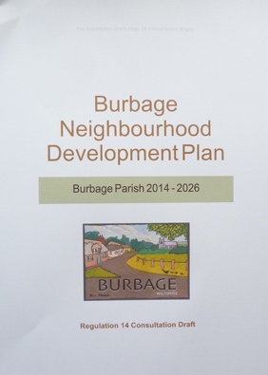 | 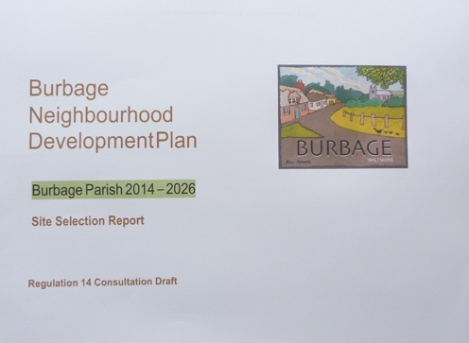 | 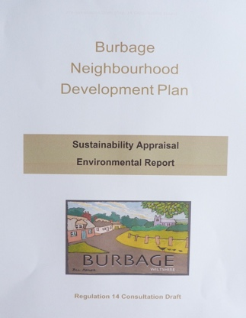
Strategy: The plan aims to encourage moderate growth in order to improve quality of life in the village and upgrade facilities, while caring for the environment including green spaces. Is the overall attitude or strategy of the plan right? Do you have any suggestions for changes?
……………………………………………………………………………………………………………………………………………………………………………………………………………………………………………………………………………………………………

Policies: do you have any specific comments on the main policies of the plan?

Policy | Comment
Development Strategy

Housing (General)

Developer Contributions

Economy
(Business, Employment, Tourism)

Green Spaces

Transport

Heritage

SITES: Do you have comments on any particular sites proposed in the plan?

…………………………………………………………………………………………………………………………………………………………………………………………………………………………………………………………………………………………………………………………………………………………………………………………………………………………………………………………………………………………………………………………………………………………………………………………………………

General Comments and Suggestions:
(Have we missed anything? Do you support the Plan? Is there anything we should change?)

………………………………………………………………………………………………………………………………………………………………………………………………………………………………………………………………………………………………………………………………………………………………………………………………………………………………………………………………………………………………………………………………………………………………………………………………………………………………………………………………………………………………………………………………………………………………………………………………………………………………………………………………………………………………………………
………………………………………………………………………………………………………………………………………………...

